Newcastle Basketball is seeking expression of interest from uniform and apparel suppliers to join in a partnership to support the association moving forward.
Interested suppliers will have until 5 pm August 31, 2021, to submit an expression of interest answering points in this document. Submissions should be emailed to admin@newcastlebasketball.com.au
Suppliers will then be contacted if more information is required and to discuss aspects of their submissions.
A decision will be made in September regarding the ongoing contract.
The contract will commence immediately.

Newcastle Basketball:
Newcastle Basketball offers an inclusive, safe and friendly environment for participation in various community activities with a primary focus on Basketball. We have a growing membership of 4000 and an increased presence in the Newcastle Community. With a 10-court facility due in the next 12 months, the association sees a significant increase in Basketball and membership expanding.
Newcastle Basketball offers the following programs to the community:
- Mini Hoops (3-5-year-old)
- Aussie Hoops (5-12-year-old)
- Junior Competitions
  - Under 8s & 10s
  - Winter Comp
  - Summer Junior Comp
- Senior Competitions
  - Monday, Tuesday & Thursday night
- Representative Basketball
- Academy Development Programs
- Officials and Coaching Development Programs
Basketball Community Foundation
Newcastle Basketball has recognised a need to support disadvantaged members in our community. Through the Basketball Community Foundation, Newcastle Basketball will support disadvantaged youths to ensure continued participation in Basketball. The association aims to run two yearly events that will help support the foundation.

Contact Information:
Newcastle Basketball
Phone: (02) 49613185
Email: admin@newcastlebasketball.com.au
Website: https://www.newcastlebasketball.com.au/
Facebook: https://www.facebook.com/newcastlebasketball

Apparel Requirements
AREA | Garments | Qty | Design Cycle | Order Cycle | Event Date | Merchandise
Staff | - Shirts  - Tracksuit Tops |  | As required | As required |  | No
Casuals | - Shirts  - Jumpers  - Caps | 100+ | As required | As required |  | No
Development – Mini Hoops | - Basketball Singlets  - Shorts | Approximately 75-100 a year | 3 years | Annually | February  April  July  October | No
Development – Officials / Referees | - T-Shirt  - Shorts |  | As Required | Annually |  | No
Development - Academy | - Basketball Singlets  - Warm-Up Tops  - Jumper | 200 | 3 years | Annually | April - September | Yes
Development – Under 8s & 10s | - Basketball Singlets  - Warm-Up Tops  - Jumper  - Caps  - Shorts  - Socks | 300+ | 3 years | Annually | February  April  July  October | Yes
Competitions - Winter Junior Club | - Basketball Singlets  - Warm-Up Tops  - Jumper  - Caps  - Shorts  - Socks | 2000+ | 3 years | Annually | April - September | Yes
Competitions -Summer Junior | - Basketball Singlets | ? | 3 years | Annually | October - April | No
Competitions -Seniors | - Basketball Singlets | ? | 3 years | Annually | All Year | No
Representative Juniors | - Basketball Singlets  - Warm-Up Tops  - Jumper  - Caps  - Shorts  - Tracksuits  - Socks  - Staff Apparel  - Backpacks | 200 | 3 years | Annually | April - September | Yes
Representative Seniors | - Basketball Singlets  - Warm-Up Tops  - Jumper  - Caps  - Shorts  - Tracksuits  - Socks  - Staff Apparel | 75 – 100 | 3 years | Annually | April - September | Yes

Please answer the questions on pages 3, 4 & 5 of the EOI.
If you have any further information you wish to provide with the EOI, it can be submitted to admin@newcastlebasketball.com.au by 5 pm August 31, 2021.
Contact Details
Company Name
Contact Name
Contact Email
Contact Phone
Company Location

Order, Supply & Delivery
Please answer the following questions regarding your order, supply and delivery capability.
How long is your order to delivery process made in Australia (working days)?
How long is your order to delivery process made overseas (working days)?
Do you have a minimum ordering quantity across all items?
Do you offer a pick and pack service?
Do you have a stock holding inventory management system?
Do you have manufacturing facilities in Australia?

Design
Please answer the following questions regarding your design capability.
Do you have internal design capability based in Australia?
Have you prepared an apparel design guide before?
Can you supply a sizing kit?
How long is your design process?

Merchandising
Please answer the following questions regarding your merchandising capability.
Would you like to commercialise a range of apparel for Newcastle Basketball?
Do you have the capability to run an online store for NB?

Technology, Research and Development
Please answer the following questions regarding your technology, research and development capability.
Can you enable the secure carriage of personal data collection devices?
Can you provide access to the most effective manufacturing techniques?
Can you customise ranges and offer off the shelf options?
Do you utilise the latest up to date technical apparel?
Do you own your manufacturing premises in Australia
Do you own/partner with manufacturing premises off sure? If so, where?
Do you support human rights as defined by the Universal Declaration of Human Rights regarding forced labour, human trafficking and modern slavery?

Items
Please indicate what garments you would be interested in supplying Newcastle Basketball. If there is a minimum order run, please indicate this number as a guide.
 | Yes/No | Min Order.
Performance Team Kit – On Court:
Example: Playing Shorts, Singlets, Socks
Performance Team Kit – Off Court:
Example: Shorts, Polos, Tracksuits, Hoodies, Jackets, Socks, Warm-up Tops
Travel:
Example: Large Travel Bags, Backpacks
Corporate & Staff:
Example: Polo, Shirts, Jackets, Caps.

Other
We would be available to travel to Newcastle to discuss options with the staff.
Do you supply any other NSO, SSO or LSO in NSW?
Do you offer fixed pricing for the term of the agreement?

Terms of Agreement
Please indicate your preferred terms:
We would prefer an exclusive arrangement
We are open to a multi-supplier arrangement by garments
We would commit to a multi-year agreement
We would provide you value in kind in exchange for negotiated marketing and promotional rights and/or a commercial agreement.
We would provide you with cash in exchange for negotiated marketing and promotional rights and or a commercial agreement.
We would be interested in learning more about the Basketball Community Foundation (a community program for disadvantaged youth) and becoming a potential community partner. Our investment would enable kids to participate in Basketball who would generally miss out.
We would offer a rebate on merchandise sold online.
As part of the submission, Newcastle Basketball would like to see design options for singlet and merchandise using the following logos and clubs:
Newcastle Basketball  Colours: Red, White & Blue  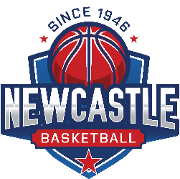 | Basketball Community Foundation  Colours: Red, White & Blue  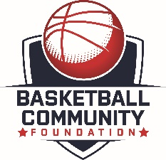
Bishop Tyrrell Basketball Club  Colours: Navy Blue & White  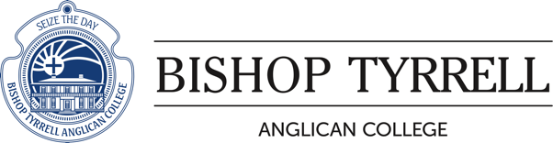 | City Limits Basketball Club  Colours: Black, White & Red  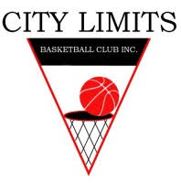 | Lakers Basketball Club  Colours: Black & Red  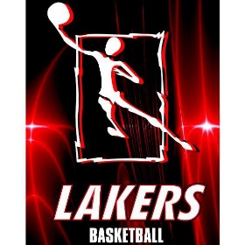
Port Hunter Basketball Club  Colours: Black & Yellow  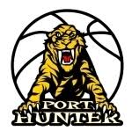 | West (Newcastle) Basketball Club  Colours: Green & Red  